Cl and SO4, Dionex ion chromatograph
This is the protocol used for running SMARTX / Biogeochemistry Lab samples as of 2021.
Materials
- 1.5ml plastic Dionex vials with caps (enough for all your samples + spikes + any reruns)
- Styrofoam or plastic vial tray to organize vials
- ZnAc/NaOH preserved porewater samples
- 10ml Rainin pipette with tip (for DI, can reuse) *ensure Disp setting is 2 or less
- 0.5-10 uL OR 10-100uL Pipetman pipette (depending on DF) with tips (1/sample, do not reuse)
- Cl/SO4 standards 1-5 in glass scintillation vials and SO4 spike solution (stored in BGC fridge)
- Cl & SO4 stock solutions (in fridge in Cindy Gilmour’s Lab, only need if standards are out)

Step 1: Reserve IC on Clustermarket/BookIt: under “Chemistry Guild”, find ‘Equipment-Dionex’ in Mathias 2044.
Step 2: Label vials (the week before running the IC)
- Label 1.5mL Dionex plastic vials in subplot-depth month format with sharpie (for order, including duplicates and spikes, see “IC run list for GCReW porewater sulfate and chloride”)
- Place vials in order in an empty Styrofoam vial tray
- Leave uncapped, wrap aluminum foil on top if leaving overnight

Step 3: Turn on the IC (the day before use)
- On the day that you first turn the instrument on, locate the green book to the right of the computer. Write in the date, your project (eg.,‘SMARTX’), the Pump_ECD psi and the CDtot background conductivity.
- Ensure that the 2 eluent jars on top of the instrument are topped off with DI (DI flask next to instrument).
- Check waste container and empty into sink.
- Log into Dionex computer (no server connection, use login/password on sticky note), open Chromeleon software.
- Navigate to “Instruments” tab (the Dionex components may already be on; check this before doing these steps)
  - On “Pump ECD” tab adjust flow rate to 0.50, turn pump on (click “on” button).
  - Wait about 20 seconds, watching the pressure rise (do not let it get above 3500psi), then lower the flow to 0.25 by pressing enter on keyboard. Wait until the pressure goes down and starts to stabilize.
  - Turn on CRTC and adjust the concentration to 32mM and clicking “on” button
    - In tests between 35 and 32 mM, the 32mM concentration yielded much better separation of the Cl- and SO4 peaks. Erika Koontz used 32 mM exclusively for her samples and had great separation for samples ranging from freshwater to 70 ppt salt water.
  - Turn suppressor on by clicking “on” button.
  - If each component has successfully turned on you will see the red square turn green next to each component.
  - Select “Monitor Baseline” (computer graph icon), select all boxes and click “Okay”. Right click on graph and click “autosize”.
  - Wait until the detection limit (CD total) and the pressure are stable at <0.5 and <3000psi (better if closer to <2500psi) respectively (this takes ~2hrs but the preference is to let the IC warm up overnight if time allows).

Step 4: Set up sample run in Chromeleon
(can be done anytime, regardless if IC is on)

- Only ~50 samples should be run at a time. (Test show a decrease is sulfate the longer samples sit in Dionex vials)
- Open Chromeleon
- On “data” tab, select the “Biogeochemistry” folder, select a file you want to copy the layout of, select “file” “save as”, change date and file name and save.
- Edit your injection list as you see fit (change your sample names). The software works similarly to Excel with copy/paste of cells and rows.
  - Tip: to save time, save an excel sheet in Biogeochem folder on desktop with your sample names in order, copy/paste to Chromeleon.
  - Suggested order of blanks, standards, samples, duplicates, and spikes is in “IC run list for GCReW porewater sulfate and chloride”
  - Click “Save file” button whenever you make changes! (button is in the top left, NOT file save as)
- GCReW Sample ID Format: “Plot_Depth_Month_Test” (Test=SPK or DUP to indicate spike or duplicate and is left blank otherwise) Example: 610_10_September_DUP, L18_20_July, SC4_40_May_SPK. (case sensitive)
- GCReW File Naming Format: “Run Number_Experiment_Analyte_(Month and Plot of first sample on the plate)”, Example: 7_SMARTX_SO4_Cl_(Sept 610)

Step 5: Pull samples from freezer to thaw (morning of analysis)
- Ensure samples are completely thawed before pipetting or samples will be inaccurately haline due to brine extrusion from ice structure.
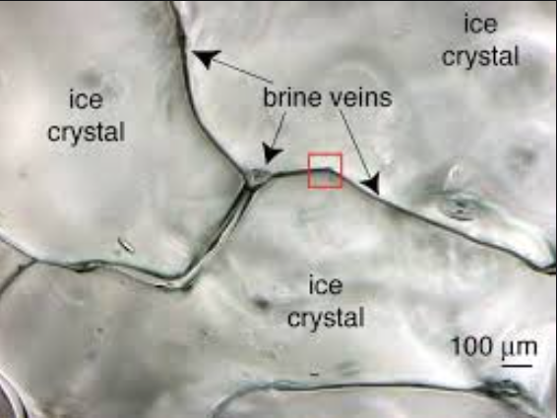 Thanks, polar oceanography
Step 6: load standards and blank (morning of analysis)
- Retrieve standards from container in Biogeochem fridge. Label Dionex vials for each standard and add 1.5 mL of each standard to their respective vial. Add DI water to Dionex vials for blanks.
- If standards in glass scint vials are low, make more from Cl & SO4 stock solutions according to ratio at the end of this SOP.
- Load standard and blank vials into Dionex and ensure their position is correctly entered in the injection list.
- Double check that the instrument method is “4 anion standard 32mM isocratic” and the processing method is “SO4_Cl standard” (both columns in the injection list)
- Double check that the Dilution factor is set to 1 for all blanks and standards and the correct dilution for your samples, dups, and spikes (you may have to scroll right for this column to be visible).
Step 7: Start run
- Go to “Instruments” tab, click computer graph button, click “stop”. Background monitoring must be turned off before the instrument runs.
- From injection list in “Data” tab:
  - Click arrow on green “start” button, “add to queue”
  - Click arrow on green “start” button, “view queue”
  - Click “ready check”
  - Make sure “keep instrument ready” is selected from drop down menu, otherwise IC will shut off after running last sample (if you want IC to shut off, can change to “run smart shutdown” at any time).
  - If no error appears, click “run” button
- Each sample takes ~10-12.5 minutes to run. It will take ~1.5 hours for the IC to run the initial standard curve and blanks so use this time to dilute your first batch of samples.

Step 8: Dilute and load samples
(ongoing, begin right after starting a run)

- Once your sample is thawed, check your sample for salinity if you don’t have a good idea of what it should be. Pipette 30 uL using manual pipette with yellow tips onto the refractometer. Record the salinity and use this to choose your dilution factor.
- Choose your dilution factor from the table below. If your dilution is higher than 150x, then you will need to use a vessel (such as a 15 or 50 mL centrifuge tube) to mix by shaking your sample, then pipette 1.5 mL into the Dionex vial.
Here is a helpful table of dilutions and volumes of sample + DI to combine:
Dilutions that can be done in the 1.5 mL Dionex Vial:
Big Pipette DI (mL) | Sample (mL) | Sample to add (uL) | Final Volume (mL) | Dilution | Salinity (ppt)
1.40 | 0.1 | 100 | 1.5 | 10 | 1.0
1.44 | 0.06 | 60 | 1.5 | 25 | 2.5
1.47 | 0.03 | 30 | 1.5 | 50 | 5.0
1.48 | 0.02 | 20 | 1.5 | 75 | 7.5
1.485* | 0.015 | 15 | 1.5 | 100 | 10.0
1.49 | 0.01 | 10 | 1.5 | 150 | 15.0
Diluted Volumes Exceeding 1.5 mL total volume:
2.97 | 0.03 | 30 | 3.00 | 100 | 10.0
5.22 | 0.03 | 30 | 5.25 | 175 | 17.5
5.97 | 0.03 | 30 | 6.00 | 200 | 20.0
7.47 | 0.03 | 30 | 7.50 | 250 | 25.0
8.97 | 0.03 | 30 | 9.00 | 300 | 30.0
9.72 | 0.03 | 30 | 9.75 | 325 | 32.5
10.47 | 0.03 | 30 | 10.50 | 350 | 35.0
11.22 | 0.03 | 30 | 11.25 | 375 | 37.5
11.97 | 0.03 | 30 | 12.00 | 400 | 40.0
12.72 | 0.03 | 30 | 12.75 | 425 | 42.5
13.47 | 0.03 | 30 | 13.50 | 450 | 45.0
14.97 | 0.03 | 30 | 15.00 | 500 | 50.0
15.72 | 0.03 | 30 | 15.75 | 525 | 52.5
20.97 | 0.03 | 30 | 21.00 | 700 | 70.0

Tip: Pipette sample on to the edge of the Dionex vial (above the level of DI) to avoid re-aspirating the sample when withdrawing the pipette.
For bolded sample volumes, use the 0.5-10 uL pipette from the BGC lab.
*The 100x dilution is used for SMARTX and LTREB samples. For the 100x dilution, you also need to use the 0.5-10 uL pipette to add a small volume of DI (1.48 mL from big pipette, plus 0.005 mL (5 uL) from small pipette).

If you do the dilutions correctly, the resulting Cl- value in micro siemens will be between 500 and 600 on the Dionex chromatograph.
- Dilute porewater samples
- Using 10mL automatic pipette in basic mode or manual pipette, dispense the appropriate amount of DI into each labelled 1.5mL Dionex vial OR into a centrifuge tube, if dilution is higher than 150x. Designate a DI tip for this purpose to reuse.
*CRITICAL*: ensure the Disp speed is 2 or less, otherwise the tip may dispense an extra drop of DI in vials at random, messing up the dilution!
- Thoroughly SHAKE/VORTEX your porewater sample vial and withdraw the amount of sample you need for your dilution.
  - All GCReW porewater samples must be shaken/vortexed to obtain accurate data
- Using 100uL single channel pipette, dispense appropriate amount of sample into Dionex vial (up to 150x dilution)*.
  - For greater than 150x dilution, use a 15 or 50 mL centrifuge tube to combine DI and sample, then pipette out 1.5 mL into the Dionex vial.
- Cap and invert.
*Remember to dispense samples in duplicates and spikes.
*Leave spike vials uncapped until all samples in the tray are dispensed.
- Using 100uL single channel pipette, dispense the spikes, cap and invert. You may also want to vortex the spike solution before dispensing, and vortex the Dionex vial after adding the spike.
  - SO4 spike: 10 µL of 250 µg/mL SO₄ standard

- If adding samples while the Dionex is running, check that the light on the autosampler that indicates needle movement is off. Then quickly remove tray from Dionex and load samples left to right.
- Option: Make an Excel spreadsheet with your sample name and dilution, to make copying and pasting into Chromeleon much easier!
  - Standard/Blank names: 1. Color 2. Letter 3. Number (RA1)
  - Sample names: 1. Color 2. Letter 3. Number (RB1)
*Important: Ensure the injection needle is not down when removing or inserting Dionex trays!
  - Check that sample name on injection list matches name on Dionex vial.
  - Check that position on injection list matches position in tray.
  - To fill injection list positions faster, select cells, click “fill down” button.
*click “save” after editing injection list
- Continue labeling vials, diluting samples, and adding to the injection list until all the Dionex trays are full.
Step 9: Monitoring your run, things to check for to make sure the Dionex is happy
- Go to “data” tab to see the status of a run. Green bar means sample is running. Double click on thumbnail to enter studio and see individual chromatogram (unless the same says ‘Finished’, it won’t let you see the chromatogram in the studio- it will still show you progress in the little thumbnail next to your sample name, however).
- Check standard curve r² for Cl and SO4
  - Double click on the peak thumbnail for one of the standards to enter studio and see individual chromatogram.
  - Click on the Cl or SO4 peak on the chromatogram to see the corresponding standard curve. make sure all standards are on the line of best fit and r² is at least 0.99.
  - If your standards are not showing up on the curve, go back to the ‘Data’ page and make sure that under ‘Type’ = Calibration Standard and ‘Level’ = 01 for Standard 1, 02 for Standard 2, etc. Chromeleon will auto-update what you change.
  - Then, go back to the graph of the standards and you should see them highlight yellow as you click on them in the left side of the program.
- Stay and watch your first sample (not a standard or DI) inject and see the progress on the chromatogram. If it goes well, then this is an indication that your run will go well. Usually, if problems are going to happen (in my experience (EK)), they will occur right away.
- Go to “data” tab to see the status of a run. Green bar means sample is running. Double click on thumbnail to enter studio and see individual chromatogram.
- If a Windows update occurs, this will pause your run (even if it doesn’t look paused). Don’t do a Windows update during your run!
- If you are running multiple days in a row, make sure to top off the DI (Eluent) at the end of every day and the morning of each new day. It goes through a good amount of Eluent, so it is important to keep it topped off.
  - Record the psi of the Pump_ECD and the background conductivity each day that you run in the green book (to the right of the computer).

Step 10: After your run: getting your data and slowing the IC down
- If you are done actively running (but plan to do re-runs in a few days or in 1-2 weeks), change these things on the IC:
  - Change the eluent concentration to 2 mM
  - Change the flow rate from 0.250 mL/min to 0.100 mL/min
- If you noticed that your dilution was entered incorrectly, change it in the ‘Data’ tab- it will auto update the amount calculation when you do this.
- At very end of the run, under consumables inventory click on EGC500 KOH, record cartridge remaining percentage in the green book
  - If remaining percentage is <25%, alert Genevieve, Pat, and Ally Soren so they can order another KOH cartridge to have ready when the old one reaches zero. The instrument will run normally until the percentage is zero. The cartridges are $1500 so we want to ensure we completely use each one.
- Download the data:
  - Double click on random sample thumbnail
  - “Peak results” tab on bottom indicates which anion
  - In “Summary” tab, copy columns A-H to excel sheet for SO4, D-H for Cl
  - Save copied data from Dionex computer as an Excel file (not csv). Use thumb drive or emails to transfer file to a computer connected to the S drive.
  - GCReW File Naming Format: “Run Number_Experiment_Analyte_(Month and Plot of first sample on the plate)”, Example: 7_SMARTX_SO4_Cl_(Sept 610)
  - Use SO4 & Cl Raw Dionex Data Processing.R to process each run. This code formats the raw data, check spikes and dupes and calculates salinity. Note this code will not run properly if sample IDs or file names do not follow the standard format described in this protocol.
  - If >20% of the Duplicates fail the processing checks, all samples in the run will need to be prepared again and rerun.
  - When all samples for the year have been run 0-Complie and QAQC SO4 & Cl Data.R code is used to QAQC and compile the annual data.

Helpful Tips

- Once it runs a sample the Dionex no longer connects that sample with its position. So it’s fine to “reuse” a position in the same run. To maximize samples run per day, swap out (in batches) previously run Dionex vials with new vials by simply adding to the injection list. To minimize mix-ups, only do this once you have become familiar with the process.
- Store run vials in labelled bags in the Biogeochem fridge. Toss only after processing and checking the data.
- Do not leave Dionex running overnight on the last day of each month! The Smithsonian restarts all the computers and your run will be interrupted. Also do not perform a Windows update in the middle of a run. The run will be interrupted.
- Periodically check the waste container and empty into sink.
- Periodically top off the eluent containers with DI (do this at the end of each run day and at the beginning of the next run day).
- If you are running the instrument continuously for a few days, periodically check your standards/blank and top them off if needed. To make more standards, see instructions on last page of this SOP.
- Needle issues: the needle was accidentally bent and then re-straightened (quick fix) in winter 2019. If you run into problems with the needle injecting in the wrong spot, click “AS-AP Self Test” (under the “Sampler” tab, IC must be on but not running), which recalibrates the needle spatially.
- Switching columns:
The default column in the Dionex is the AS18. We also own an AS11 for organic acid anion analysis. If you want to swap out the column, check with Sean Hartnett (mercury lab tech) and put a sign up on the Dionex. Each column has two parts: a guard column (shorter) and a regular column (longer) and they are installed in tandem. To install, open up the side and unscrew/screw in the 2 components. All the connections are finger tight. The liquid goes through the guard column first and then the normal column, so it’s important to put them in the correct orientation (there are flow arrows on each piece) and to check that the guard and regular column match.

Troubleshooting: What to do when…

Issue 1: The IC was ready to run, and almost passed the ready check. When the run was started, the IC slowed the flow rate to 0.1 mL/second and pressure dropped by half (2500psi -> 1100 psi). Yellow error bar shows up saying “CHECK!!! Make sure that the purge valve screws is(are) open.”
    - Cause: bubble in line, otherwise the system is fine. You need to flush out the bubble.
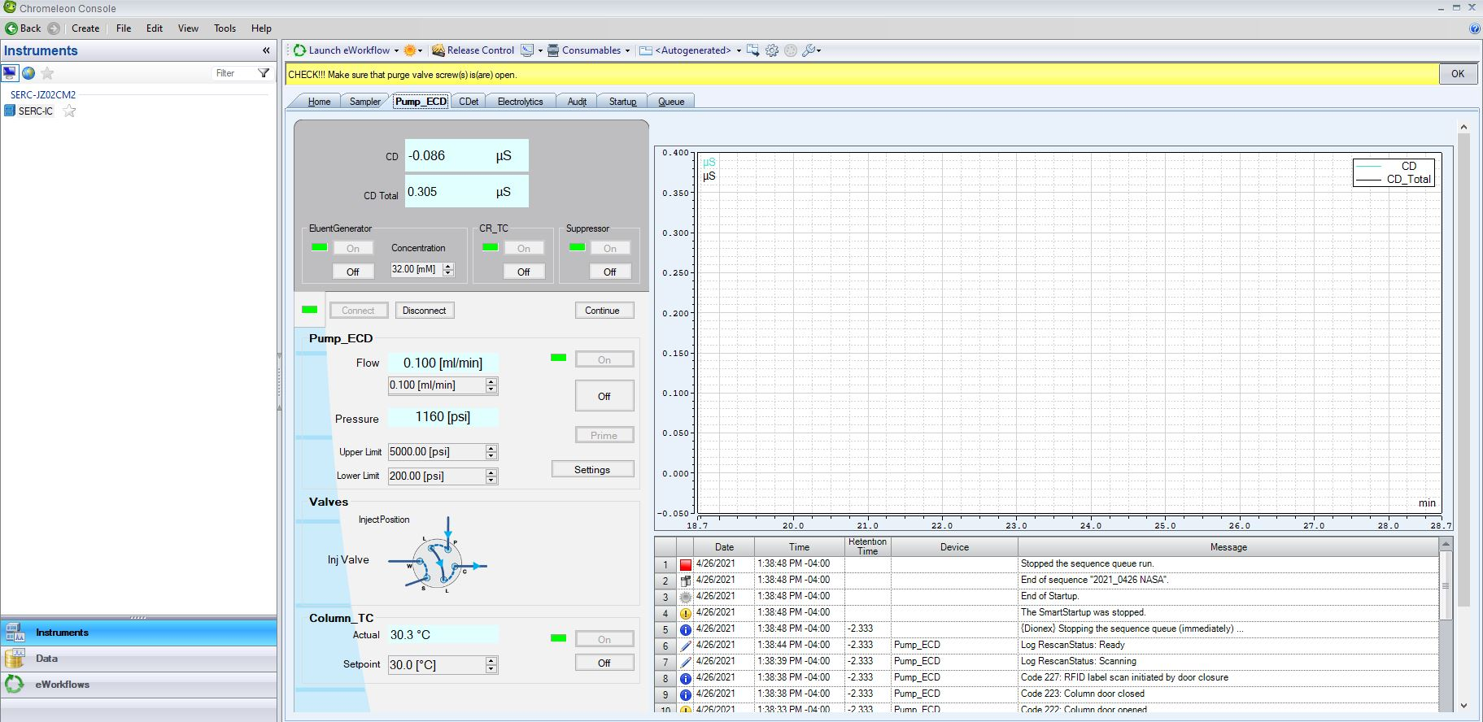
    - Why does this happen? It occurs after the system has been sitting for a while (after a week of no use).

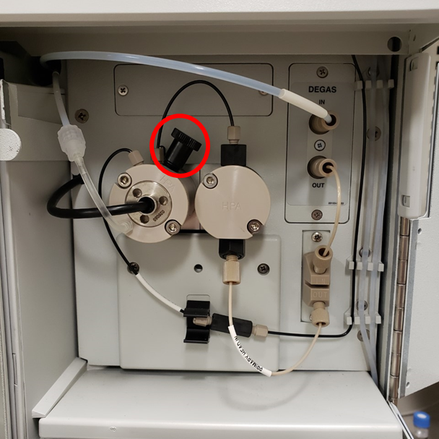
How to Fix It:

- Open top door on right side of machine.
- Look for and locate bubble (see photo for example of a bubble).
- If you found a bubble in the line, note this, and then go to the Instrument page.
- Under the Pump_ECD tab, turn on background monitoring to specifically view the pump pressure.
- Turn OFF the EluentGenerator, CR_TC, and the Suppressor. Then, turn off the Pump_ECD. Watch as the pressure drops (should drop quickly) to less than 100 psi.
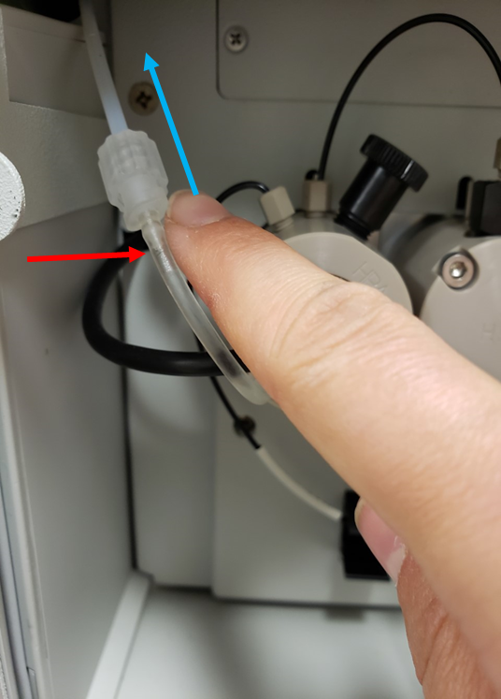
- Once the pressure is below 100 psi, locate the black knob (red circle in photo) on the top right side of the lefthand pump.
Flow direction; watch for the bubble to flow out.
- Unscrew the pump valve ½ a turn (righty-tighty, lefty-loosey).
- For the Pump_ECD, press “Prime”. The machine will give you a warning and ask if you are sure that you want to do this. Accept the error and proceed with the priming. The pump will make a good amount of noise, and you should keep the door open to WATCH where the bubble goes. It should flush OUT, and in the direction of the blue arrow.
Bubble in line
- Let it pump for ~30 seconds, OR until you see no more bubbles. It should not take very long at all.
- When you see no more bubbles, with one hand on the mouse and one hand on the pump valve, turn OFF Prime and tighten the knob to a STRONG finger-tight (once you think it is tight, try to tighten it a little bit more. This is important!).
- Turn everything back on: EluentGenerator, CR_TC, Suppressor, and Pump_ECD. You should see the pressure go back up to ~2500 psi, and the flow should be at 0.250 mL/min. At this stage, you can run some DI and/or standards through, as the pressure and background conductivity stabilizes. In an hour or two you can run samples, as long as background conductivity (~0.360) and the pressure looks good (~2500 psi).

Issue 2: Communication error between computer and Dionex, run stops during a sample, but stays green and says “RUNNING”, even though it isn’t. Message in the console, viewable on the Pump_ECD tab, will indicate that the method you are running hasn’t been loaded or is rejected.
Second symptom: Baseline monitoring will not show ANYTHING on the graph when selected or auto-sized.
Why does this occur? In one case, a Windows update occurred which temporarily interrupted the communication between the computer and the Dionex.
How do you fix it? Turn everything off and on again, then re-attempt your run (DI and standards first).

Making Standards
Instructions for making fresh SO4 and Cl standards from stock solutions. Prepare in existing glass scint vials stored in fridge.
- Locate 1000 µg /mL SO4 and 1000 µg /mL Cl stock solutions (stored in fridge in Cindy Gilmour’s Lab)
- Make Standard 5: 200 µg/mL Cl, 20 µg/mL SO4
  - 11.7 mL DI
  - 3 mL of 1000 µg /mL Cl stock
  - 0.3 mL of 1000 µg /mL SO4 stock
- Pipette DI into scint vials for standards 1-4 (see table for volumes)
- Vortex and then pipette Standard 5 into scint vials for standards 1-4 (see table for volumes).
- Vortex standards to mix.

Standard | Ratio Std : DI | Total Volume (ml) | Volume of DI to add (ml) | Volume of std 5 to add (ml) | Volume of std 5 to add (µl)
1 | 1 : 40 | 15 | 14.625 | 0.375 | 375
2 | 1 : 20 | 15 | 14.25 | 0.75 | 750
3 | 1 : 10 | 15 | 13.5 | 1.5 | 1500
4 | 1 : 2 | 15 | 7.5 | 7.5 | 7500
5 | 1 : 1 | 15 | 0 | 15 | 0

Making SO4 spike solution
Instructions for making fresh 250 µg/mL SO4 spike solution. Prepare in existing glass scint vial stored in fridge.
- Locate 1000 µg /mL SO4 stock solution (stored in fridge in Cindy Gilmour’s Lab)
- Make SO4 spike solution: 250 µg/mL SO4
  - 15 mL DI water
  - 5 mL of 1000 µg /mL SO4 stock
- Vortex spike solution to mix.

